


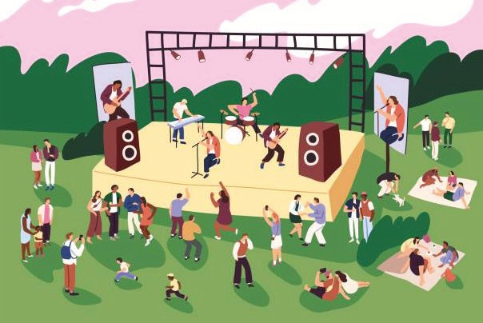
Hertfordshire’s Dementia Festival
Saturday 12 September 12pm to 4pm
Bandstand area, Fairlands Valley Park, Stevenage, SG2 0BL
afternoon of
music, entertainment
and opportunities to
connect with others in
the community.

A fun

For further information: central.herts@alzheimers.org.uk 01279 427522 (voicemail only line)
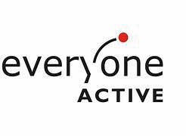



Map of festival area and parking
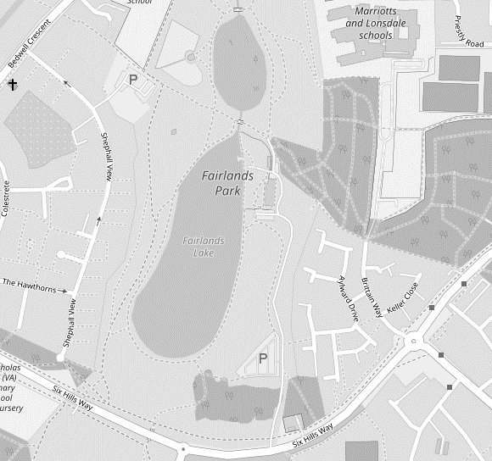



Festival area marked by the green dot – follow the paths from car parks, staff will be there to help and guide you.

Orange dot is for access to toilets, where there is also a disabled toilet available.


Blue cross is for car park A (this is a bigger car park) – Use SG2 0BL for sat nav, five minutes’ walk to area.


Black cross is for car park B – use SG2 0BL for sat nav, drive past main car park and follow road round to café parking (a very small car park) five minutes’ walk to festival area.

